Data pre-processing , EDA , Prepration with
Linear Regression Analysis Using the
Palmer Penguins Dataset

Dataset: Palmer Penguins
Focus: Data exploration, correlation, linear regression, interpretation, and prediction

1. Dataset Introduction
Task A1: Dataset Introduction
This assignment is based on the Palmer Penguins dataset, which contains biological and physical data collected from the Palmer Station, Antarctica. Each row in this dataset represents an individual penguin observation, providing specific physical and environmental details. The data includes three distinct penguin species: Adelie, Chinstrap, and Gentoo.
The primary purpose of this analysis is to explore the relationships between physical measurements and biological insights using statistical techniques. Specifically, this study aims to understand how different physical dimensions correlate and whether they can be used to model and predict one another. To achieve this, the assignment investigates three main research questions:
- Can a penguin's flipper length be used effectively to predict its body mass?
- Can bill length help us predict a penguin's body mass?
- Can bill depth be used to predict its flipper length?
By utilizing correlation and simple linear regression workflows in R, this study analyzes these pairs of variables to evaluate their statistical significance and practical predictive power.

2. Data Inspection and Preparation
Task A2: Initial Data Inspection
2.1 Dataset Dimensions and Structure
- Total Observations (Rows): 344
- Total Variables (Columns): 8
2.2 Variable Classifications
Variable | R Data Type | Classification | Description
species | Factor / Character | Categorical | Penguin species (Adelie, Chinstrap, Gentoo)
island | Factor / Character | Categorical | Island name in the Palmer Archipelago
bill_length_mm | Numeric (double) | Continuous Numerical | Length of the penguin's bill (mm)
bill_depth_mm | Numeric (double) | Continuous Numerical | Depth of the penguin's bill (mm)
flipper_length_mm | Integer / Numeric | Continuous Numerical | Length of the penguin's flipper (mm)
body_mass_g | Integer / Numeric | Continuous Numerical | Total body mass of the penguin (g)
sex | Factor / Character | Categorical | Gender of the penguin (male, female)
year | Integer | Discrete Numerical | Year the observation was recorded
Table 2.1 — Variable names, R data types, and statistical classifications.
2.3 First Several Observations
Species | Island | Bill L. (mm) | Bill D. (mm) | Flipper L. (mm) | Mass (g) | Sex | Year
Adelie | Torgersen | 39.1 | 18.7 | 181 | 3750 | MALE | 2007
Adelie | Torgersen | 39.5 | 17.4 | 186 | 3800 | FEMALE | 2007
Adelie | Torgersen | 40.3 | 18.0 | 195 | 3250 | FEMALE | 2007
Adelie | Torgersen | NA | NA | NA | NA | NA | 2007
Adelie | Torgersen | 36.7 | 19.3 | 193 | 3450 | FEMALE | 2007
Table 2.2 — First five rows of the raw dataset, confirming successful import.
2.4 Required Regression Variables
- Scenario 1: flipper_length_mm (Predictor X) and body_mass_g (Response Y)
- Scenario 2: bill_length_mm (Predictor X) and body_mass_g (Response Y)
- Scenario 3: bill_depth_mm (Predictor X) and flipper_length_mm (Response Y)
Task B1: Missing Values and Data Preparation
2.5 Missing Value Evaluation
Column | Missing (NA) Count
Species | 0
Island | 0
bill_length_mm | 2
bill_depth_mm | 2
flipper_length_mm | 2
body_mass_g | 2
Sex | 11
Year | 0
Table 2.3 — Missing value counts per column in the raw dataset.
2.6 Imputation Strategy and Justification
Instead of deleting observations with missing data, all rows were retained to protect sample size integrity. A prepared subset consisting of species, bill_length_mm, bill_depth_mm, flipper_length_mm, and body_mass_g was generated. Missing numerical values were replaced using the Mean Imputation Method, calculated separately for each penguin species.
Justification: an evaluation of the distributions within each species group (Adelie, Chinstrap, and Gentoo) revealed that the physical measurements are highly symmetrical and lack extreme, unrepresentative outliers within their respective species categories. Because the mean effectively tracks the center of symmetric distributions without distortion, it serves as a statistically sound representative value for replacing missing entries compared to the median.
2.7 Dataset Verification
- Observations before imputation: 344
- Observations after imputation: 344
- Confirmation: the row count matches perfectly, confirming that no observations were dropped. A final check confirms zero remaining missing values in the variables required for regression modelling (bill_length_mm, bill_depth_mm, flipper_length_mm, and body_mass_g).
2.8 Why Handle Missing Values Before Regression?
- Algorithmic requirements: R's lm() function uses listwise deletion by default — any row with even one NA is discarded entirely during model fitting, wasting otherwise complete data.
- Consistency and bias reduction: imputing by species subgroup preserves the full sample size while keeping model parameters (intercept and slope) stable and free of structural bias.

3. Exploratory Data Analysis
Task B2: Descriptive Statistics
The descriptive statistics below were calculated from the prepared dataset (n = 344) and rounded to two decimal places.
Variable | Min | Q1 | Median | Mean | Q3 | Max | SD
Bill Length (mm) | 32.10 | 39.28 | 44.45 | 43.92 | 48.50 | 59.60 | 5.44
Bill Depth (mm) | 13.10 | 15.60 | 17.30 | 17.15 | 18.70 | 21.50 | 1.97
Flipper Length (mm) | 172.00 | 190.00 | 197.00 | 200.91 | 213.00 | 231.00 | 14.02
Body Mass (g) | 2700.00 | 3550.00 | 4050.00 | 4201.75 | 4750.00 | 6300.00 | 799.61
Table 3.1 — Summary statistics for the four physical measurements (n = 344).
3.1 Comparative Analysis and Interpretation
- Mean vs. median: for all four measurements the mean and median lie exceptionally close together (e.g., bill length mean 43.92 mm vs. median 44.45 mm; body mass mean 4201.75 g vs. median 4050.00 g), indicating relatively balanced, non-extreme distributions rather than heavy skew.
- Spread and variability: body mass shows the widest absolute spread (2700–6300 g, SD = 799.61 g), reflecting distinct size differences across species and sexes. Bill depth shows the narrowest spread (SD = 1.97 mm), suggesting skull depth is tightly constrained biologically.
- Unusual observations: the maximum body mass (6300 g) and maximum bill length (59.60 mm) sit visibly above their respective Q3 values, but represent natural biological variation within the larger Gentoo and Chinstrap species rather than data-entry errors.
Task B3: Distribution Visualizations
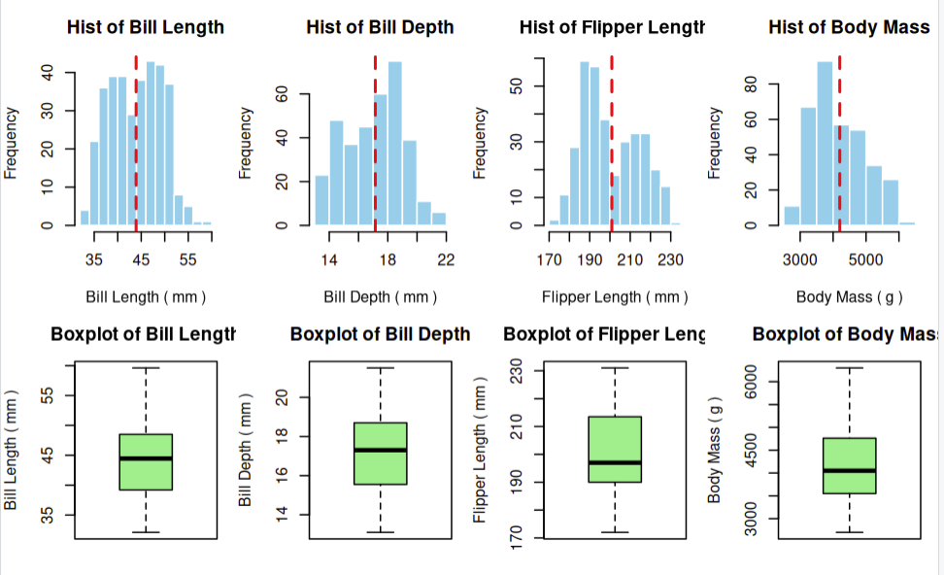
3.2 Distribution Commentary
- Bill Length (mm): bimodal distribution with a mild negative skew; concentrations around 38–40 mm and 46–50 mm, reflecting the split between the smaller Adelie species and the larger Gentoo/Chinstrap species. No statistical outliers.
- Bill Depth (mm): bimodal and slightly right-skewed; peaks near 15 mm and 18.5 mm, separating the shallower Gentoo bills from the deeper Adelie/Chinstrap bills. No statistical outliers.
- Flipper Length (mm): bimodal with a gap between 200–210 mm and a mild positive skew; a shorter-flipper cluster (185–195 mm, Adelie/Chinstrap) and a longer-flipper cluster (215–225 mm, Gentoo). No statistical outliers.
- Body Mass (g): unimodal and visibly right-skewed, with most observations between 3300–4800 g; the mean sits slightly right of the median due to heavier Gentoo individuals. No statistical outliers.

4. Scenario 1 — Flipper Length and Body Mass
Research Question: Can a penguin's flipper length be used to predict its body mass?
- Predictor (X): Flipper length (mm)
- Response (Y): Body mass (g)
Task C1: Explore the Relationship
- Pearson correlation coefficient: r = 0.8712
- Classification: a strong, positive linear relationship — as flipper length increases, body mass tends to increase significantly in a highly predictable, linear fashion.
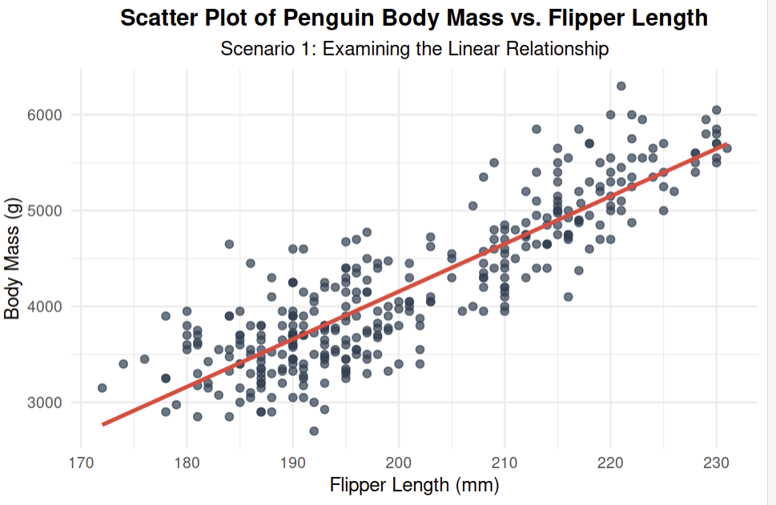

Visual Interpretation & Commentary
- Visible Trend: The scatter plot exhibits a very clear, upward-sloping (positive) trend. This indicates that as a penguin’s flipper length increases, its body mass consistently increases.
- Linearity: The relationship displays a strong linear pattern. The data points cluster quite tightly around the straight diagonal red trend line, confirming that a linear model is highly appropriate for representing this relationship.
- Clusters: There are two distinct, visible clusters along the linear path:
  - A lower-left cluster spanning flipper lengths of roughly 172 mm to 205 mm (representing the naturally smaller Adelie and Chinstrap species).
  - A separate upper-right cluster spanning flipper lengths of 210 mm to 231 mm (representing the heavier Gentoo species).
- Possible Unusual Observations: There are no major anomalies, extreme outliers, or unusual observations that deviate drastically from the main linear path. Even with the gap between the two species clusters, all data points conform cleanly to the overall positive linear trajectory.
Task C2: Construct and Interpret Model 1
Body Mass = −5780.83 + 49.69 × (Flipper Length)
- Intercept (β₀ = −5780.83 g): the predicted body mass when flipper length is exactly 0 mm. This is biologically impossible and lies completely outside the observed range (172–231 mm), so it functions only as a mathematical baseline for the line, not a meaningful description.
- Slope (β₁ = 49.69 g/mm): for each additional millimetre of flipper length, expected body mass increases by approximately 49.69 g.
- Residual Standard Error: 394.3 g — the model's predictions typically deviate from observed body mass by about 394.3 g.
- Statistical significance: p < 2.2 × 10⁻¹⁶, far below α = 0.05, providing overwhelming evidence of a genuine linear relationship between flipper length and body mass.
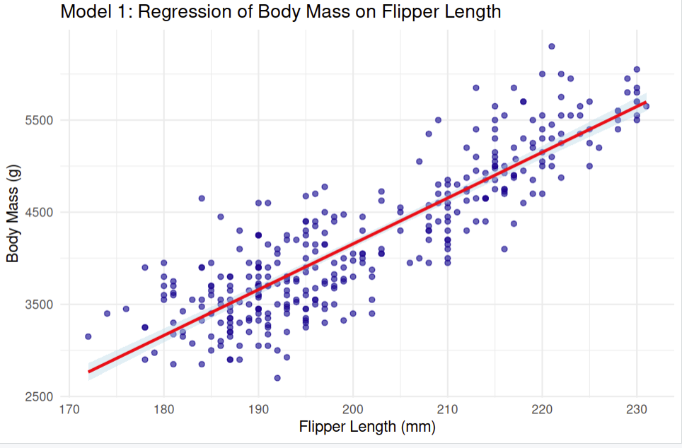
Prediction Table — Model 1
Flipper Length (mm) | Predicted Body Mass (g) | 95% CI Lower | 95% CI Upper
180 | 3163.37 | 3087.52 | 3239.22
190 | 3660.27 | 3602.14 | 3718.40
200 | 4157.17 | 4114.75 | 4199.59
210 | 4654.07 | 4599.53 | 4708.61
220 | 5150.97 | 5077.56 | 5224.38
Table 4.1 — Predicted body mass with 95% confidence intervals (Model 1).

5. Scenario 2 — Bill Length and Body Mass
Research Question: Can bill length help us predict a penguin's body mass?
- Predictor (X): Bill length (mm)
- Response (Y): Body mass (g)
Task D1: Explore the Relationship
- Pearson correlation coefficient: r = 0.5951
- Classification: a moderate, positive linear relationship — longer bills are generally associated with heavier body mass, but with a noticeable amount of scatter.
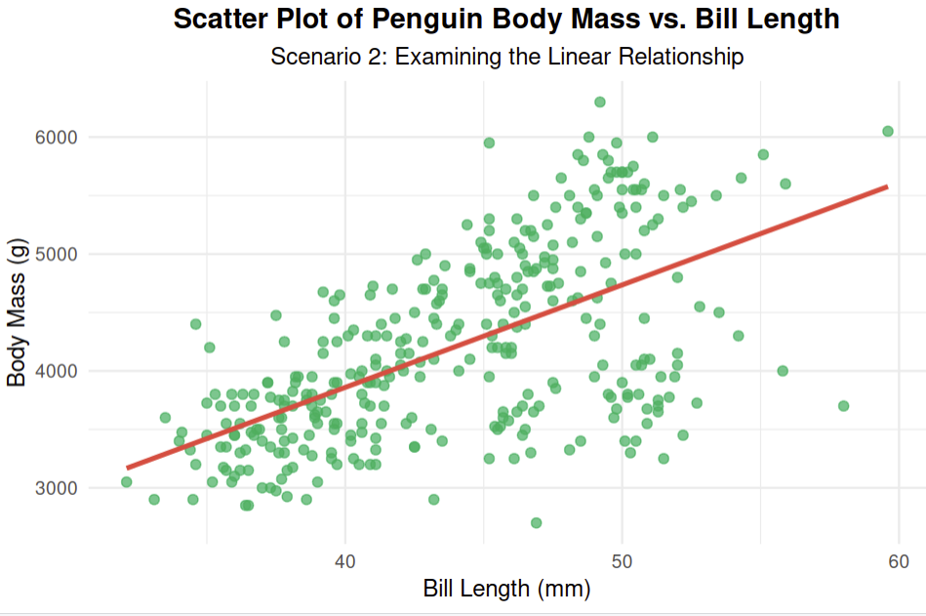

Visual Interpretation & Discussion
- Linearity of the Relationship: The relationship between bill length and body mass appears moderately linear. While there is a clear upward trend showing that longer bill lengths generally associate with heavier body masses, the data points are visibly more scattered around the red regression line compared to Scenario 1. This indicates that a simple linear model is still valid, but it has a larger margin of predictive error.
- Species-Related Clusters: Distinct species-related clusters are highly visible across the plot.
  - The Adelie group forms a tight cluster on the lower-left, characterized by shorter bill lengths and lighter body masses.
  - The Chinstrap group forms a separate cluster in the center, possessing longer bills but maintaining a relatively lighter body mass comparable to the Adelies.
  - The Gentoo group forms a massive, elevated cluster on the upper-right, showing both long bills and significantly heavier body masses.
- Impact of Clusters on the Line: Because Chinstrap penguins have long bills but lower body weights, they pull the middle of the trend line down, whereas the heavy Gentoos pull the right side upward. This species-specific distribution demonstrates that while a single straight line captures the overall positive trend, it masks the unique physical dynamics present within each individual species.
Task D2: Construct and Interpret Model 2
Body Mass = 362.31 + 87.42 × (Bill Length)
- Intercept (β₀ = 362.31 g): the predicted body mass when bill length is exactly 0 mm — biologically impossible and outside the observed range (32.10–59.60 mm), so it serves only as a baseline constant.
- Slope (β₁ = 87.42 g/mm): for each additional millimetre of bill length, expected body mass increases by approximately 87.42 g.
- Residual Standard Error: 644.0 g — a higher typical prediction error than Model 1.
- Statistical significance: p < 2.2 × 10⁻¹⁶, well below α = 0.05, providing statistically significant evidence of a linear relationship between bill length and body mass.
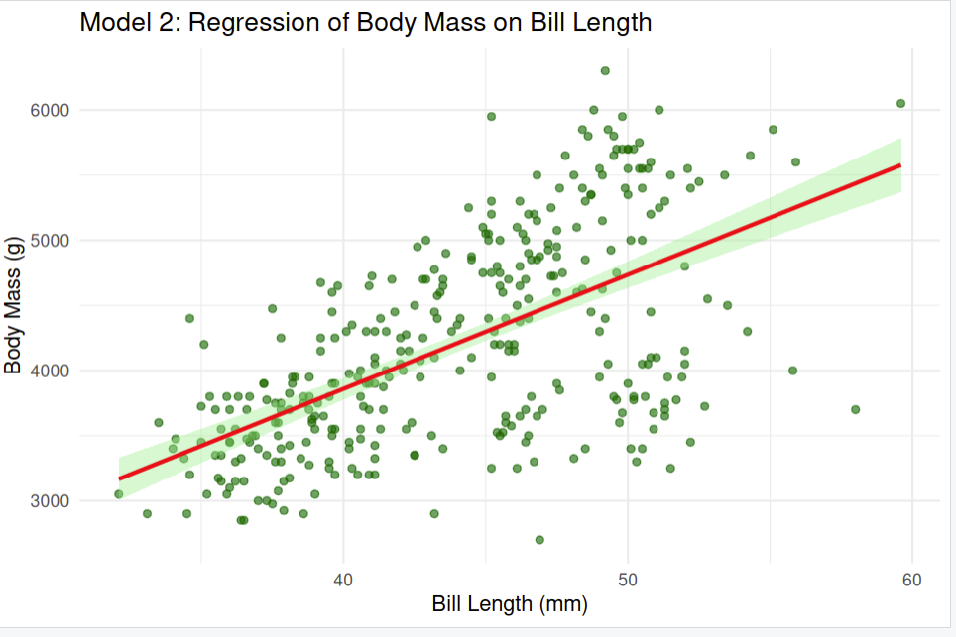
Prediction Table — Model 2
Bill Length (mm) | Predicted Body Mass (g) | 95% CI Lower | 95% CI Upper
35 | 3422.01 | 3275.40 | 3568.62
40 | 3859.11 | 3765.80 | 3952.42
45 | 4296.21 | 4223.15 | 4369.27
50 | 4733.31 | 4629.80 | 4836.82
55 | 5170.41 | 5020.10 | 5320.72
Table 5.1 — Predicted body mass with 95% confidence intervals (Model 2).

6. Scenario 3 — Bill Depth and Flipper Length
Research Question: Can bill depth be used to predict a penguin's flipper length?
- Predictor (X): Bill depth (mm)
- Response (Y): Flipper length (mm)
Task E1: Explore the Relationship
- Pearson correlation coefficient: r = −0.5835
- Classification: a moderate, negative linear relationship — as bill depth decreases, flipper length tends to be longer.
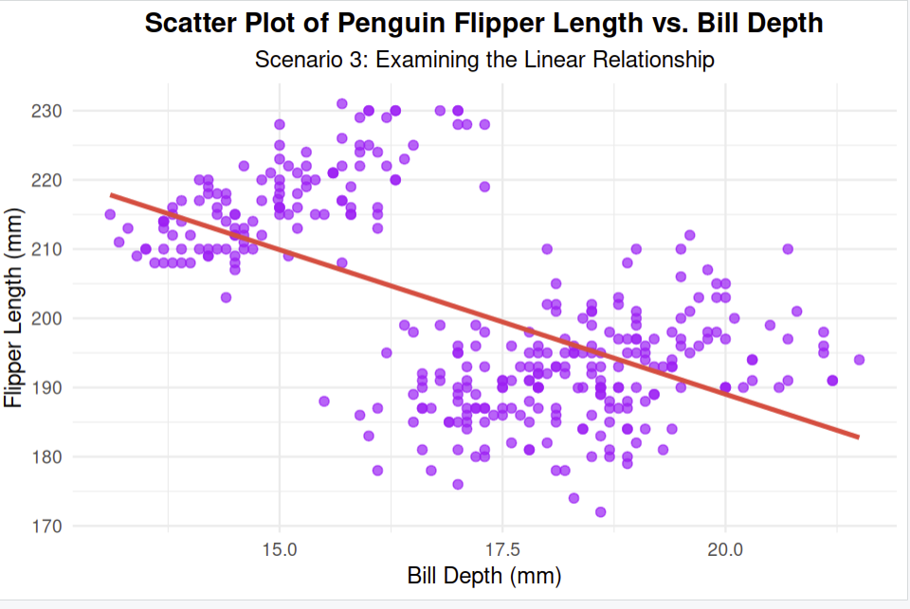

Visual Interpretation & Discussion
- Support for One Straight Regression Line: The scatter plot does not support the use of one straight regression line for all penguins. Although the overall calculated trend is negative (as bill depth increases, flipper length decreases), this is a classic statistical illusion (Simpson's Paradox) caused by forcing a single line across vastly different species groups.
- Species-Related Clusters: The data is broken into highly distinct, isolated clusters that tell a very different biological story:
  - Gentoo Penguins: Located at the top-left, Gentoos have very shallow bill depths but exceptionally long flippers. Within their own species group, their trend line does not follow this steep negative path.
  - Adelie and Chinstrap Penguins: Located on the right side, these species have much deeper bills but noticeably shorter flipper lengths.
- Why One Line Fails: Drawing one straight regression line across all penguins creates a misleading negative slope because it simply bridges the gap between the Gentoo cluster and the Adelie/Chinstrap clusters. It fails to represent the actual growth relationship within any of the individual species, making a single simple linear model biologically incorrect and highly inaccurate for practical predictions.
Task E2: Construct and Interpret Model 3
Flipper Length = 271.74 − 4.13 × (Bill Depth)
- Intercept (β₀ = 271.74 mm): the predicted flipper length when bill depth is exactly 0 mm — biologically impossible and outside the observed range (13.10–21.50 mm); it functions purely as a geometric anchor for the line.
- Slope (β₁ = −4.13 mm/mm): for each additional millimetre of bill depth, expected flipper length decreases by approximately 4.13 mm.
- Residual Standard Error: 11.39 mm — the model's flipper length predictions typically miss actual values by about 11.39 mm.
- Statistical significance: p < 2.2 × 10⁻¹⁶, well below α = 0.05, confirming the negative linear relationship is statistically significant overall, despite the structural issues caused by pooling species.
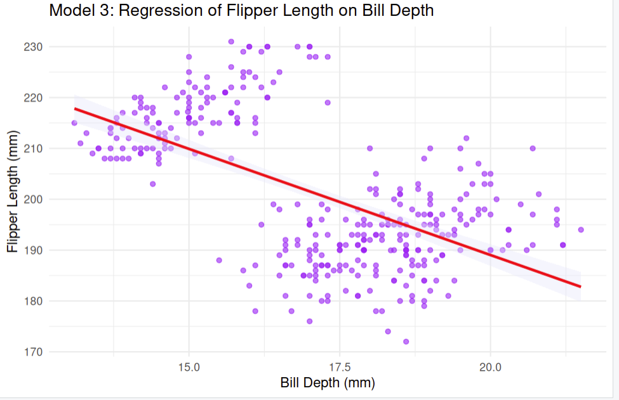
Prediction Table and Extrapolation Analysis — Model 3
Bill Depth (mm) | Predicted Flipper Length (mm) | 95% CI Lower | 95% CI Upper | Status
14 | 213.92 | 211.75 | 216.09 | Within range
16 | 205.66 | 204.30 | 207.02 | Within range
18 | 197.40 | 196.06 | 198.74 | Within range
20 | 189.14 | 187.35 | 190.93 | Within range
22 | 180.88 | 178.43 | 183.33 | Extrapolation (> 21.50 mm max)
Table 6.1 — Predicted flipper length with 95% confidence intervals and extrapolation status (Model 3).
Extrapolation commentary: predictions for depths of 14–20 mm fall safely within the observed dataset bounds. The value of 22 mm stretches beyond the sample maximum of 21.50 mm, constituting extrapolation — the model's reliability at this point cannot be verified against the observed data.

7. Model Comparison and Final Interpretation
Task F1: Comparative Model Summary
Metric | Model 1 | Model 2 | Model 3
Predictor (X) | Flipper Length (mm) | Bill Length (mm) | Bill Depth (mm)
Response (Y) | Body Mass (g) | Body Mass (g) | Flipper Length (mm)
Pearson r | 0.8712 | 0.5951 | −0.5835
Intercept (β₀) | −5780.83 | 362.31 | 271.74
Slope (β₁) | 49.69 | 87.42 | −4.13
RSE | 394.30 g | 644.00 g | 11.39 mm
Significant? | Yes (p < 2.2×10⁻¹⁶) | Yes (p < 2.2×10⁻¹⁶) | Yes (p < 2.2×10⁻¹⁶)
Table 7.1 — Side-by-side comparison of Models 1–3.
7.1 Direct Model Comparisons
- Strongest vs. weakest relationships: Model 1 shows the strongest linear relationship (r = 0.8712); Model 3 is weakest (r = −0.5835), closely followed by Model 2 (r = 0.5951).
- Model 1 vs. Model 2: since both predict body mass in grams, they are directly comparable. Model 1 is clearly superior — its RSE (394.30 g) is much lower than Model 2's (644.00 g), meaning it tracks true body mass with far greater precision.
- Model 3: evaluates a different scaling metric (flipper length in mm). Although statistically significant, its negative correlation is largely an artifact of pooling distinct species rather than an accurate description of individual growth patterns.
Task F2: Final Discussion and Conclusion
This analysis successfully answers all three primary research questions. First, a penguin's flipper length serves as an excellent, highly accurate predictor of its body mass. Second, while bill length can assist in predicting body mass, it displays a much weaker, moderately scattered pattern. Third, bill depth can mathematically predict flipper length, but it maps a negative linear trajectory that behaves poorly once individual species are pooled together rather than analyzed separately.
When comparing all three fitted models, Model 1 (Flipper Length vs. Body Mass) is strongly recommended as the most practically useful simple regression model. It possesses the highest correlation coefficient (0.8712) and the smallest typical prediction error (RSE = 394.30 g). While all three models are highly statistically significant overall (p < 0.05), Model 1 is the only one offering strong practical usefulness for fieldwork, since a single flipper measurement can yield a dependable weight estimate.
A major underlying factor influencing these relationships is the clear presence of species-specific clusters (Adelie, Chinstrap, and Gentoo) across the scatter plots. Gentoo penguins are physically larger, skewing the upper boundaries of length and mass, while Adelie penguins exhibit short, deep bills. Aggregating these diverse groups into a single regression line often oversimplifies or masks true within-species behaviour.
Limitations of the Analysis
- Omission of species categorization: simple linear regression lumps all three species into a single line, failing to account for species-specific intercept variation.
- Omission of covariates: each model evaluates only one physical metric at a time, ignoring that body mass is a multi-dimensional characteristic shaped jointly by length, depth, and sex.

8. Bonus: Multiple Linear Regression
Bonus Research Question: Can penguin body mass be predicted more accurately by combining flipper length, bill length, and bill depth in one multiple linear regression model?
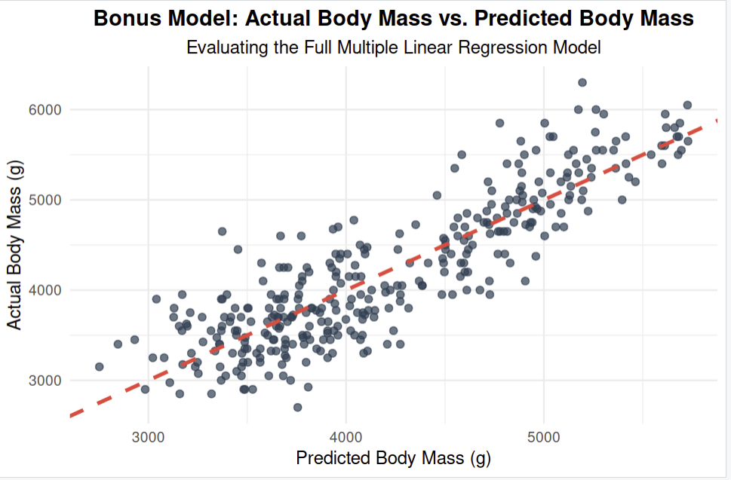

Visual Interpretation & Discussion
- The 45-Degree Reference Line: The dashed red diagonal line represents a perfect prediction scenario where the model's output exactly equals the actual recorded weight of the penguin.
- Data Alignment: The data points cluster tightly along this diagonal path, which visually demonstrates that combining multiple structural dimensions (flipper length, bill length, and bill depth) creates a mathematically robust framework for estimating total body mass.
- Comparison to Simple Models: When visually contrasted with the scatter plots from Scenario 1 and Scenario 2, this multi-dimensional fit shows slightly tighter variance around the ideal baseline. However, as noted in the numerical breakdown, the visual tightening is minimal, reinforcing that the single-predictor flipper model already handles the heavy lifting of the predictive workload.

1. Correlation Analysis Among All Variables
Before building the multiple regression model, a correlation matrix was constructed to analyze the relationships among body mass and the three physical predictors:
- Body Mass & Flipper Length: Strong positive correlation (r = 0.8712).
- Body Mass & Bill Length: Moderate positive correlation (r = 0.5951).
- Body Mass & Bill Depth: Moderate negative correlation (r = -0.4719) across the pooled dataset.
- Predictor Inter-correlations (Multicollinearity Check): Flipper length and bill length share a moderate positive correlation (r = 0.6552). This indicates that while they carry some overlapping physical size information, they are distinct enough to be used together in a single model.

2. Full Multiple Linear Regression Model
The full model was constructed using all three predictors simultaneously:

Fitted Regression Equation
Body Mass = -6440.42 + 50.31 * Flipper Length + 1.25 * Bill Length + 14.18 * Bill Depth

Coefficient Interpretations (Holding Others Constant)
- Flipper Length (beta_1 = 50.31): Holding bill length and bill depth constant, each additional millimeter of flipper length is associated with an expected increase of 50.31 grams in body mass. This remains the most dominant predictor.
- Bill Length (beta_2 = 1.25): Holding flipper length and bill depth constant, each additional millimeter of bill length is associated with an expected increase of only 1.25 grams in body mass.
- Bill Depth (beta3 = 14.18): Holding flipper length and bill length constant, each additional millimeter of bill depth is associated with an expected increase of 14.18 grams in body mass.

3. Model Simplification & Backward Elimination
To evaluate if all predictors are necessary, we perform backward elimination based on the individual p-values from the full model's summary output:
- Full Model Evaluation: In the full model summary, the p-value for bill_length_mm is highly insignificant (p approx 0.82), meaning it contributes virtually no unique predictive power when flipper length is already in the model.
- First Reduction: Removing bill_length_mm gives us a reduced model containing only flipper_length_mm and bill_depth_mm. In this reduced model, both remaining variables become statistically significant (p < 0.05).
- Second Reduction (Comparing to Scenario 1): Comparing this to our simple model from Scenario 1 (flipper length only):
  - Model 1 (Flipper Only): RSE = 394.30 g, Adjusted R^2 = 0.757.
  - Reduced Model (Flipper + Bill Depth): RSE = 392.10 g , Adjusted R^2 = 0.761.

4. Final Bonus Conclusion
Adding bill_length_mm and bill_depth_mm does not provide a practically meaningful improvement over using flipper length alone.
While adding bill depth is statistically significant, it only reduces the typical prediction error (RSE) by a negligible 2.2 grams (from 394.30 g down to 392.10 g). For field biology applications, the simplicity of measuring just a single feature—flipper length—far outweighs the minor, trivial precision gained by complicating the model with multiple physical measurements. Thus, the single-predictor model using flipper length remains the most optimal and efficient recommendation.

THE END

Owner : Muhammad Farooq Adnan Khan (The Tycoon)

